QUY TRÌNH PHÁT TRIỂN 1 MODULE CHO VIETNAMNET

1. **Cấu trúc layer**

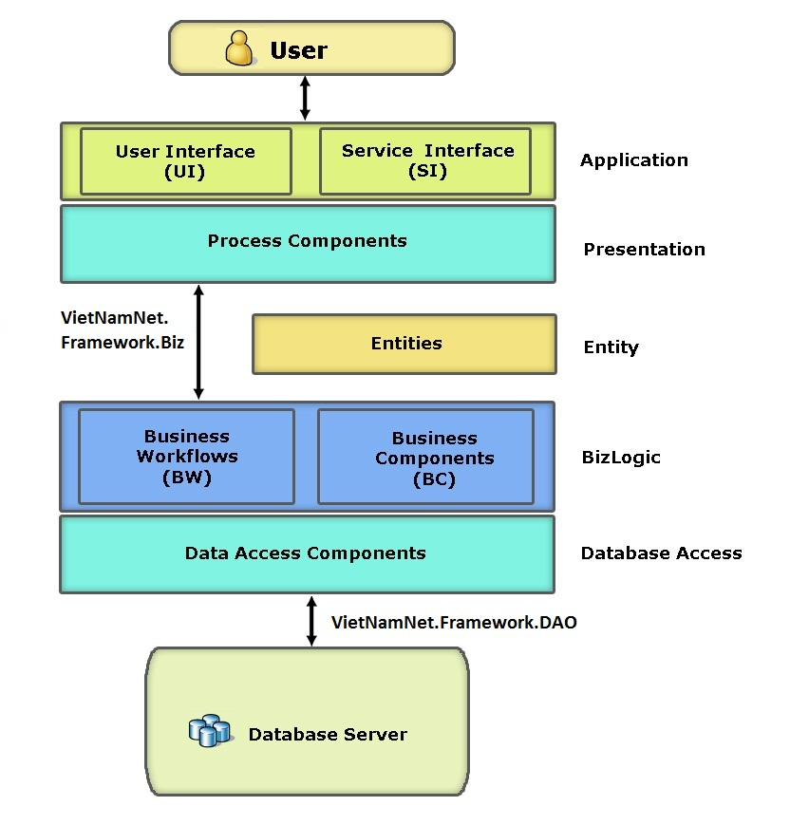

1. **Base object**
2. VietNamNet.Framework.Module
   1. BaseEntity
   2. BaseObject
   3. BaseServices
   4. ModuleConstants
3. **Cấu trúc module**
4. UI
   1. Front-end
      1. View : Default.Master
      2. Display : Default.Master
      3. Edit (add new, update) : Default.Master
      4. Popup (option) : Popup.Master
   2. Code behind
      1. View: BasePageView
      2. Display: BasePage
      3. Edit: BasePage
      4. Popup: BasePage
      5. Dùng chung:
         1. Initialize
            1. moduleAlias
            2. viewAlias
            3. addNewAlias
            4. updateAlias
            5. deleteAlias
         2. PageLoad
5. Layers
   1. Object : BaseObject

Các thuộc tính của object

* 1. Presentation – Helper

Các function

* 1. BizLogic – Manager : Façade

Xử lý các tác vụ Business Logic

* 1. DBAccess – DAO : BaseDAO

Access database

* 1. Constant
     1. Entity : BaseEntity
     2. Service : BaseServices
     3. CommandNames : Module.CommandNames
     4. FormName : Module. FormName
     5. ParameterName : Module. ParameterName
     6. Message : Module. Message
     7. ConfigKey : Module. ConfigKey
     8. ViewState : Module. ViewState
     9. Session : Module. Session
     10. EmailTemplates : Module. EmailTemplates
     11. ConnectorString : Module. ConnectorString

1. Utility - Utils